Supply Chain Management (SCM) — NPTEL
Week 12 · Session 2: Industry 4.0 Pillars 1–3: IoT, Cloud Computing & H/V System Integration
1. Recap & Session Scope
- Session 1 (Week 12): Digitization vs Digitalization pyramid, Industry 4.0 intro, 4 industrial revolutions, 9 pillars overview, 5 SC applications
- This session: deep dive into Pillars 1, 2 & 3 — IoT, Cloud Computing, and Horizontal/Vertical System Integration
- Remaining 6 pillars: Cyber Security, Big Data Analytics, Simulation, AR, Robots, Additive Manufacturing — covered in subsequent sessions

★ IoT, Cloud, and H/V Integration work as a system: IoT collects data → Cloud stores and shares it → H/V Integration defines who it flows to and in what direction.
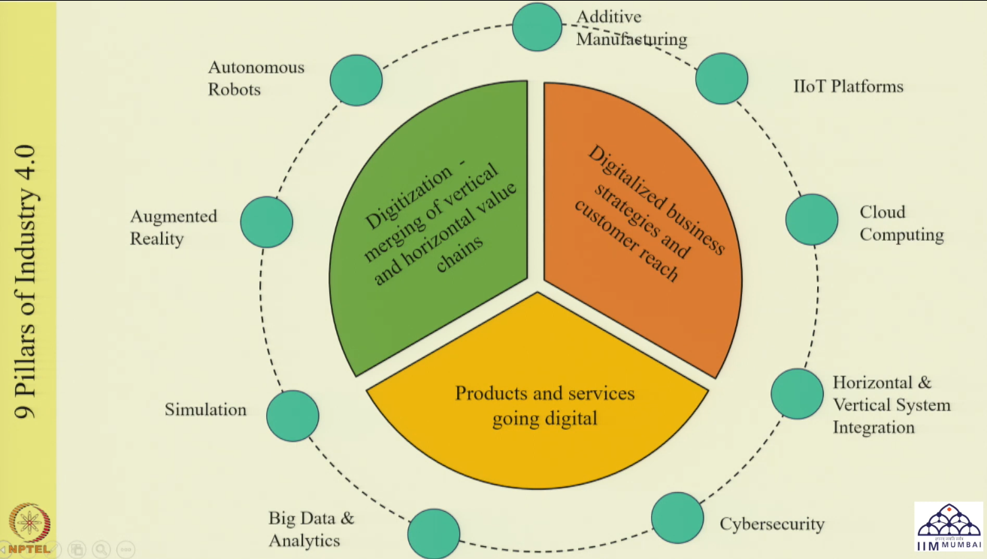
Pillar 1 — IoT (Internet of Things)

3. What is IoT?
- Definition: a network of interconnected physical devices, vehicles, buildings and other objects embedded with sensors, actuators and connectivity
- Role: collects data from the physical world and exchanges it — enabling digital representation of real-world events
- Bridges the gap between the physical world and the digital world
- Supports real-time insights and automation capabilities — without human intervention

RFID & GPS — Key IoT-Adjacent Technologies
- RFID (Radio Frequency Identification): tracks and manages inventory and assets using embedded chips and readers
- GPS (Global Positioning System): determines location of shipments and vehicles in real time
- Both serve the IoT data-collection purpose — not strictly IoT devices but integral to IoT ecosystems

4. How IoT Works — 4-Step Sequence
1 | Collect | Devices, sensors (e.g., temperature sensor), RFID and GPS capture data from the physical world  Mode: online or offline depending on process requirement  Select technology based on what you need to measure (temp, location, vibration, etc.)
2 | Communicate | Captured data is sent to a central system or destination over the internet  Protocols must be followed for secure transmission  Communication channels: Wi-Fi, Bluetooth, LPWAN, or direct internet connection
3 | Analyze | Data is processed and analyzed — can happen in cloud or at the edge  Visualization, reports, outlier detection, anomaly identification  Insights are extracted; any critical condition triggers an alert
4 | Act | Based on analysis, automated or manual actions are initiated  Forms: alerts, emails, notifications, automated control signals  Closes the loop: physical event → digital capture → decision → physical response

Technology Dependencies in the IoT Sequence
- Step 2 (Communicate) relies on Cloud Computing — the next Industry 4.0 pillar
- Step 3 (Analyze) relies on Big Data Analytics — another Industry 4.0 pillar
- IoT is not standalone — it requires 3–4 Industry 4.0 technologies working together

5. Three Types of IoT
Type | Usage, Data Volume & Examples
IIoT Industrial IoT | Used in industrial and manufacturing environments — instrumentation, MES (Manufacturing Execution Systems)  Enables machine-to-machine (M2M) communication and process automation  Generates large volumes of high-frequency process data; insights for production optimization  Example: automated conveyor system, predictive maintenance sensors on factory equipment
CIoT Consumer IoT | Used by individuals or households in everyday life  Wearables (smartwatches), smart home appliances, personal monitoring devices  Data volume is small; connects to mobile apps for individual tracking and monitoring  Example: fitness tracker sending health data to a phone app
CmIoT Commercial IoT | Used in commercial premises for operational monitoring and management  Applicable in office buildings, supermarkets, hotels, hospitals  Applications: environmental monitoring, lighting control, asset tracking  Data is collected to a centralized database or cloud → analytics + monitoring

★ IIoT generates the most data (industrial processes). CIoT generates the least (personal devices). CmIoT covers commercial premises. All three route data to a central system for analytics.

6. IoT Applications in Supply Chain
4 Key SC Applications
- Real-time inventory & resource tracking: visibility of inventory location and quantity at all SC nodes
- Predictive maintenance: sensors analyze equipment condition → anticipate failure → minimize downtime by triggering maintenance before breakdown
- Inventory optimization: tracking data feeds inventory decisions → reduces both excess inventory and stockouts
- Improved decision-making: data from SC captured and analyzed → better planning insights → smarter SC decisions

7. IoT — Implementation Challenges
Challenge | Explanation
Investment Cost | Requires heavy upfront investment — infrastructure, devices, connectivity
Security & Privacy | Critical data captured at multiple points must be secured and kept private
Scalability | IoT system must handle growing data volume as more partners join the SC
Integration | Compatibility between new IoT systems and existing legacy systems is a major technical challenge
Human Behaviour | Management must approve and champion implementation — resistance and change aversion are common barriers

8. Emerging Trends in IoT for Supply Chain
- Edge Computing: process data closer to the source (at the device/sensor level) rather than sending everything to a central cloud → faster decisions, lower latency
- Blockchain Integration: ensures transparency and traceability of data collected via IoT — prevents tampering with records
- AI/ML Integration: apply predictive analytics on IoT-collected data → forecast failures, optimize routes, adjust inventory
- Environmental Impact Reduction: IoT-enabled monitoring supports sustainability goals — track emissions, energy use, waste

Pillar 2 — Cloud Computing

10. What is Cloud Computing?
- Definition: delivery of computing services — servers, storage, software, databases, networking — over the internet
- Purpose: provide flexible resources economically — no need for individual hardware/software ownership
- Economy of scale for the provider → no upfront capex for the user → win-win model
- Enables: data storage, processing, collaboration, and running AI/ML algorithms — all at scale, accessible from anywhere

Two Classification Dimensions
- Cloud computing is classified in two independent ways: by deployment model AND by service model

11. Cloud Deployment Types
Type | Who uses it / Infrastructure | Security | Examples
Public | Shared infrastructure; accessible to all; low cost | Low | Google Apps, AWS
Private | Dedicated to single org; org owns and manages infra | Highest | HPE, Dell, IBM
Community | Shared by multiple orgs with similar needs (e.g., govt agencies, universities) | Moderate | Cisco Community Cloud
Hybrid | Combination of public + private (e.g., public for web, private for customer DB) | Mixed | Azure, IBM

- Selection rule: choose based on cost vs security trade-off and whether data is sensitive
- Hybrid is most flexible — use public where cost matters, private where security is critical

12. Cloud Service Models (IaaS / PaaS / SaaS)
Model | What is provided | User Control | Example
IaaS Infrastructure as a Service | Access to hardware: storage, network, OS, virtual servers. User manages above the infrastructure layer. | Highest flexibility + control | Amazon Web Services (AWS)
PaaS Platform as a Service | Platform for app development: OS, database, programming environment, web server. User manages apps + data. | High — manages resources clearly | Microsoft Azure
SaaS Software as a Service | Access to software applications on pay-per-use basis. Most convenient — user just uses the application. | Lowest — just access the app | Gmail, Google Docs, Office 365

- Memory tip: IaaS = infrastructure (you manage most), PaaS = platform (you manage apps), SaaS = software (you just use it)
- SaaS is most common for end users — Gmail, Google Docs, Office 365 are daily SaaS examples

★ As you move from IaaS → PaaS → SaaS: user control decreases, convenience increases. IaaS gives most flexibility; SaaS gives least control but is easiest to use.

Pillar 3 — Horizontal & Vertical System Integration

14. Horizontal & Vertical System Integration
- This is a strategy rather than a standalone technology — it defines HOW IoT, cloud, and analytics are deployed
- Purpose: leverage digital technologies to transform operations and remain competitive

Type | Definition, Purpose & Example
Horizontal Integration | Connects activities operating at the SAME level — within or across organizations  Purpose: coordination and synchronization of similar functions  Example: integrating production planning + scheduling + MES (Manufacturing Execution System) across multiple factories within the same company  Benefit: better coordination between similar departments; enables collaboration between similar organizations
Vertical Integration | Connects players in SEQUENCE — upstream ↔ downstream across the SC  Purpose: end-to-end visibility, control, and optimization across the chain  Example: integrating Product Lifecycle Management (PLM) → Manufacturing Execution System (MES) → ERP → SC  Benefit: full traceability from product design through production to supply chain

Decision: Which Type to Use?
- Depends on where digital improvement is needed:
- Same-level coordination problem (e.g., factories not synchronized) → Horizontal integration
- End-to-end visibility problem (e.g., no traceability from design to delivery) → Vertical integration
- Both can be implemented together in large organizations

Session Summary
- IoT: network of connected devices that collect + communicate + analyze + act on data. Bridges physical and digital worlds without human intervention.
- IoT 4 steps: Collect (sensors, RFID, GPS) → Communicate (Wi-Fi, Bluetooth, LPWAN) → Analyze (cloud/edge, outlier detection) → Act (alerts, auto-control)
- 3 IoT types: IIoT (industrial, high volume, M2M) | CIoT (consumer, low volume, personal) | CmIoT (commercial, offices, hospitals)
- IoT SC applications: inventory tracking, predictive maintenance, inventory optimization, improved decisions
- IoT challenges: cost, security/privacy, scalability, legacy system compatibility, human resistance
- Cloud: computing services over internet — no upfront capex. Classified by deployment (public/private/community/hybrid) and service (IaaS/PaaS/SaaS)
- H/V Integration: Horizontal = same-level coordination. Vertical = sequential upstream-downstream linkage. Both enable digital transformation of operations.

★ Exam Tip: IoT 4-step working: (1) Collect (sensors/RFID/GPS), (2) Communicate (Wi-Fi/Bluetooth/LPWAN), (3) Analyze (cloud/edge + anomaly detection), (4) Act (alerts/notifications/auto-control).
★ Exam Tip: 3 IoT types: IIoT (industrial, M2M, high volume) | CIoT (consumer, personal devices, low volume) | CmIoT (commercial, offices/hospitals/hotels, asset tracking).
★ Exam Tip: Cloud deployment: Public (low cost, low security, AWS/Google) | Private (high security, single org, IBM/Dell) | Community (shared by similar orgs) | Hybrid (mix of public + private).
★ Exam Tip: Cloud service models: IaaS = hardware/infra (AWS) | PaaS = platform/dev environment (Azure) | SaaS = software access (Gmail, Office 365). Control decreases as you go IaaS → SaaS.
★ Exam Tip: H = horizontal integration (same level, e.g., production planning + MES + scheduling). V = vertical integration (sequential chain, e.g., PLM → MES → ERP → SC).

